Kolisch, Rudolf (1896-1978)
Daniel Bangert

Rudolf Kolisch was an Austrian-born violinist, teacher and conductor. As leader of the Kolisch Quartet he premiered many important chamber works by the Second Viennese School and other modernist composers of the first half of the twentieth century. He later became leader of the Pro Arte Quartet and taught at the University of Wisconsin in Madison and at the New England Conservatory in Boston.

Kolisch was born in Klamm am Semmering, Austria on July 20, 1896. His father Rudolf was a doctor and his mother Henriette, a pianist. Soon after starting violin lessons, an injury to his left hand led him to hold the violin in his right hand and bow left-handed. He attended the Vienna Music Academy and the University of Vienna, but his postgraduate studies were interrupted by three years of service in the Austrian army during World War I. His teachers included the Czech violinist Otakar Ševčík, the composer Franz Schrecker, and the musicologist Guido Adler.

In 1919 he became a composition student of Arnold Schoenberg (who would later marry Kolisch’s sister Gertrud), but soon became involved in Schoenberg’s Verein für musikalische Privataufführungen (Society for Private Musical Performances) as a performer. At Schoenberg’s urging, Kolisch formed the Vienna String Quartet in 1922. After several changes in personnel, its membership stabilised with Kolisch and Felix Khuner on violin, violist Eugene Lehner, and cellist Benar Heifetz. From 1928 the group was known as the Kolisch Quartet.

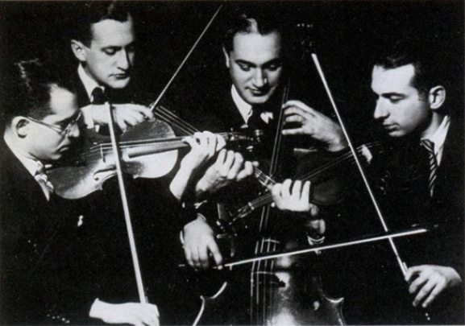

Kolisch Quartet (from left): Felix Khuner, Eugene Lehner, Benar Heifetz, Rudolf Kolisch

Note: [Image above taken from http://satyr78lp.blogspot.com.au/2012/03/kolisch-string-quartet-mozart-kv-575.html - a widely used photo for CDs etc. (copyright unclear). Other images that could be used in the entry include those in the Tully Potter Collection, such as http://www.tullypottercollection.com/browse-all-products.html?page=shop.product_details&flypage=flypage.tpl&product_id=2198&category_id=1&keyword=kolisch]

The Kolisch Quartet toured widely in Europe, but their access to some countries was restricted after Hitler’s rise due to their association with modern composers. From 1935 they performed in the USA regularly and decided to remain there. Heifetz and Lehner left the quartet in 1939 to take up orchestral positions and after continuing for a few years with other players, the Kolisch Quartet was permanently disbanded in 1944.

While they also played the standard quartet repertoire, the Kolisch Quartet were best known as advocates for new music. They worked closely with several composers, particularly Schoenberg, whose Fourth Quartet bears a joint dedication to Elizabeth Sprague Coolidge who commissioned the piece and to “the ideal interpreters of it the Kolisch Quartet.” Compositions premiered by the group include Schoenberg’s Third and Fourth Quartets and his Concerto for String Quartet and Orchestra, Berg’s Lyric Suite, Webern’s String Trio and String Quartet, Bartók’s Fifth and Sixth Quartets, Krenek’s Fifth Quartet, and Sessions’ Second Quartet. The Kolisch Quartet’s custom of rehearsing from scores and performing from memory were notable innovations in quartet playing.

Kolisch taught courses on musical performance and chamber music at the New School for Social Research in New York City from 1939 to 1941, where he also conducted the first American performances of Stravinsky’s The Soldier’s Tale, Bartók’s Music for Strings, Percussion and Celesta, and Schoenberg’s Chamber Symphony. From 1944 to 1967 Kolisch taught at the University of Wisconsin in Madison and led the Pro Arte Quartet (the first ‘quartet-in-residence’ in a major American university). In the 1950s he taught at the Internationale Ferienkurse für Neue Musik (International Summer Courses in New Music) in Darmstadt, Germany. Kolisch’s last post was at the New England Conservatory in Boston where he was a faculty member from 1967 until his death in Watertown, Massachusetts on August 1, 1978.

References and further reading

Harp, D. (1988) ‘Recalling the Kolisch String Quartet’, Chamber Music 5 (1), 19-21, 40-45. (An interview with Kolisch Quartet violist Eugene Lehner.)

Kolisch, R. (1943) ‘Tempo and Character in Beethoven’s Music’, The Musical Quarterly 29 (2-3): 169-187, 291-312. (Originally presented in 1942 at a meeting of the American Musicological Society, Kolisch’s paper was an important contribution to the debate on Beethoven’s tempi and metronome marks.)

Mell, A. (1977-78) ‘In Memoriam: Rudolf Kolisch (1896-1978)’, Journal of the Violin Society of America 4 (1), 142-46. (A brief reflection on Kolisch’s career.)

Potter, T. (2003) ‘Twelve-tone Memories: A History of the Kolisch Quartet’, In Honor of Rudolf Kolisch [liner notes]. Berkeley, CA: Music & Arts. (Notes to accompany recordings of the Kolisch Quartet performing the complete Schoenberg Quartets and other works by Bartók, Berg, Webern and Schubert, plus solo recordings by Kolisch of Schoenberg’s Violin Concerto and Bartók’s Sonata for Solo Violin.)

Shreffler, A. C. & Trippett, D. (eds.) (2009) ‘Rudolf Kolisch in America – Aufsätze und Dokumente’, Musiktheorie: Zeitschrift für Musikwissenschaft 24 (3). (Articles and documents, including lectures given by Kolisch on performance, Beethoven quartets, contemporary music, and Schoenberg. Also included is a speech by Theodor W. Adorno for Kolisch’s sixtieth birthday and the script for a radio dialogue between Kolisch and Adorno.)

Grassl, M. & Kapp, R. (eds.) (2002) Die Lehre von der musikalischen Aufführung in der Wiener Schule. Vienna: Böhlau. (Includes chapters on Kolisch by Pro Arte Quartet cellist Lowell Creitz, Kolisch’s student and teaching assistant at the New England Conservatory David Satz, and Susanna Watling.)

